|  |  |  |  |
| --- | --- | --- | --- |
| 1 | | 103,416.0 | |
| NUMERO DE FRONTERAS | | ENERGIA AGREGADA | |
|  | | | |
| SI | | 13-03-2021 | |
| CONTRATO | | VENCIMIENTO CONTRATO | |
|  | | | |
| 207,667,940 | 73 | | 7,572,109 |
| INGRESO 2019 | DÍAS CERTIFICADOS 2019 | | ENERGIA RESPALDADA 2019 |
|  | | | |
| 421,167,638 | 163 | | 16,013,687 |
| INGRESO 2020 | DÍAS CERTIFICADOS 2020 | | ENERGIA RESPALDADA 2020 |
|  | | | |
| 252,115,238 | 120 | | 11,009,306 |
| INGRESO 2021 | DÍAS CERTIFICADOS 2021 | | ENERGIA RESPALDADA 2021 |

|  |
| --- |
| **MALTERIA TROPICAL**  USUARIO |

|  |
| --- |
| **Mateo Porras**  Ejecutivo de cuenta |

|  |
| --- |
| **Francisco Santos / 0 / francisco.santos@ab-inbev.com**  PUNTO FOCAL |

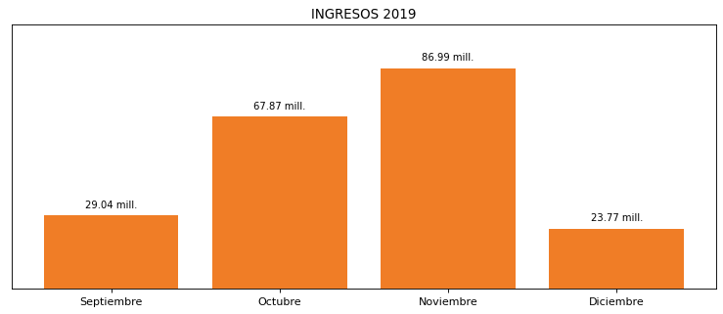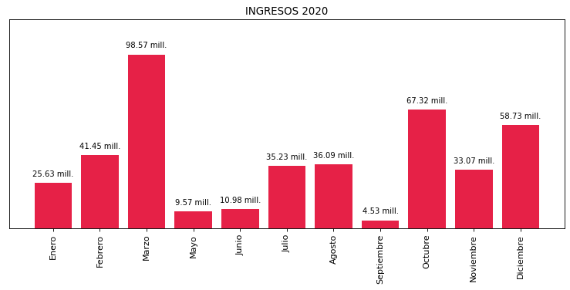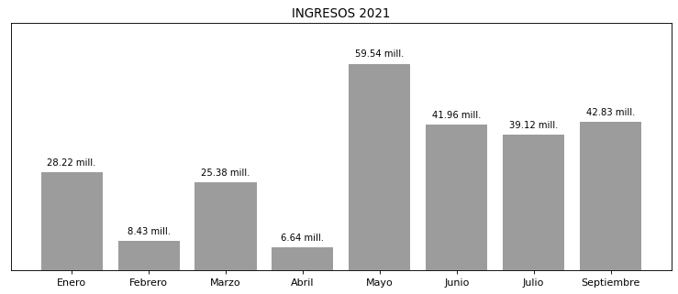

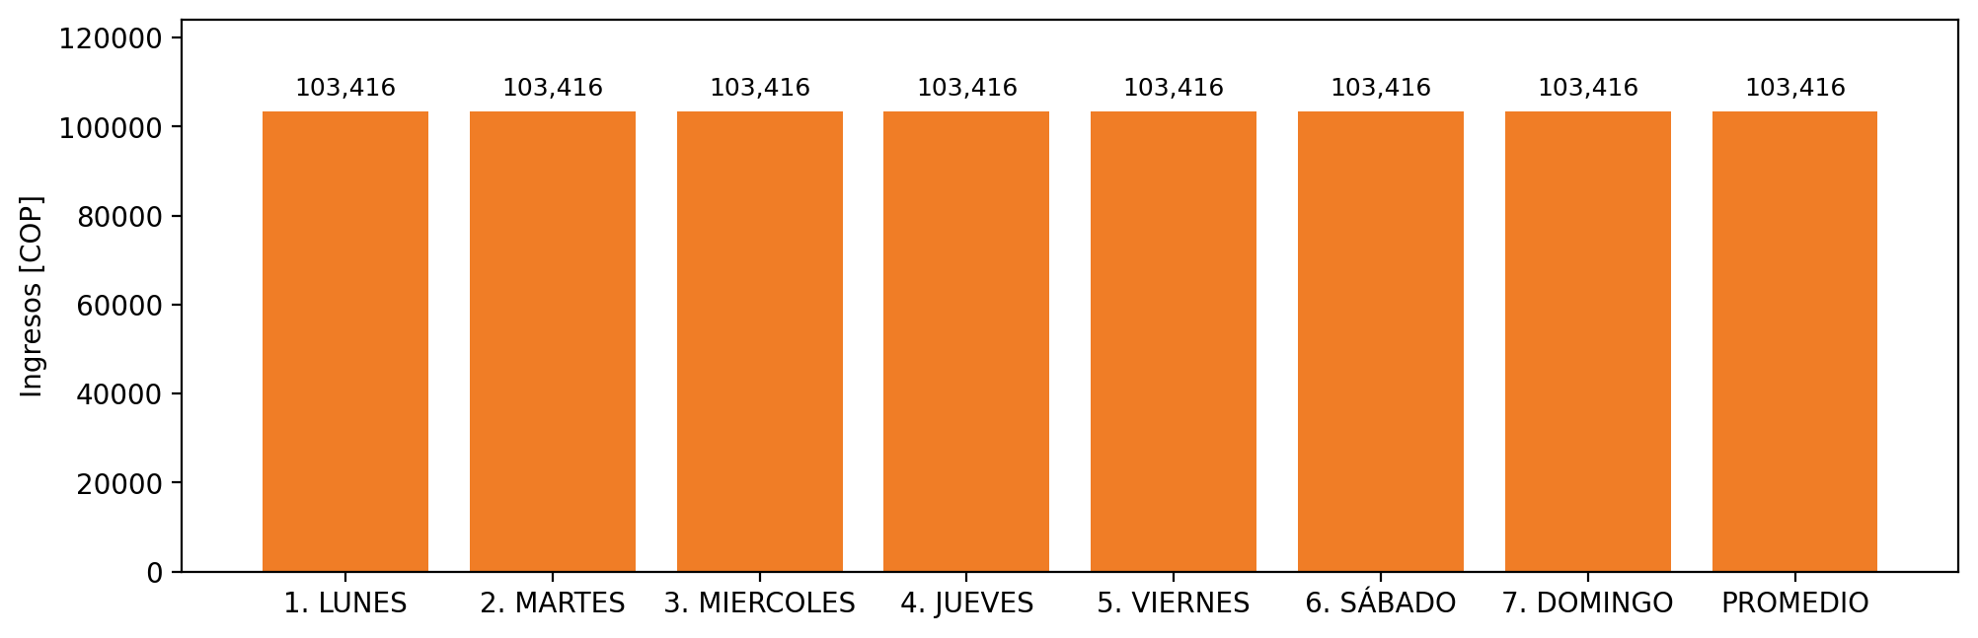

|  |  |  |  |  |  |  |  |  |  |  |
| --- | --- | --- | --- | --- | --- | --- | --- | --- | --- | --- |
| **FRONTERA** | **COD SIC** | **PREDIO** | **FRT DDV** | **TIPO DDV** | **PROMEDIO** | **PRÓXIMA ACTUALIZACIÓN** | **MARGEN DE ERROR** | **ÚLTIMA PRUEBA DDV** | **DÍAS PARTICIPACIÓN** | **FECHA REFERENCIA PRÓXIMA PRUEBA DDV** |
| MALTERIA TROPICAL S.A. - CARTAGENA | Frt01581 | Prd01329 | Frt33219 | LBC | 103,416 | 2022-02-16 | 3,77 | 2021-08-29 | 18.0 | 2022-01-19 |